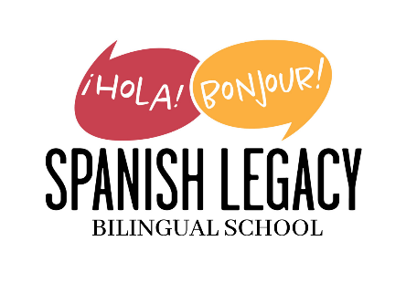
Spanish Legacy Homeschool Education Program
(Grades K-5)
Program Details: 9 a.m. to 3 p.m. Monday – Friday
Using a Montessori approach, this full-time Spanish immersion multi-age program is designed for students who are eager to explore learning in an immersive, caring, and family-like environment. Through student-centered lessons, creative activities, and project-based learning, students will develop their language skills and receive a well-rounded, student-centered education. Our curriculum includes a wide range of subjects, including Language Arts, math, social studies, science, art, theater, life skills, and more. In our program, students gain the confidence to communicate in Spanish, solve real-world problems, and truly enjoy learning in a supportive, bilingual setting. Come join our Spanish Legacy family today!
Tuition: $8,900
- Tuition is fully funded by the Step Up For Students PEP Scholarship! See Step Up letter for more details on the application process.
- Tuition payments due in August: $2,225, November $2,225, February $2,225, May $2,225
Application Fee: $500 (nonrefundable, not PEP covered)
- For Returning Students Only: Register by Wed., Feb. 26th and pay $300 application fee (nonrefundable, not PEP covered)
Supply Fee: $800 (nonrefundable, not PEP covered)
- Fall Supply Fee: $400 (due August 2025)
- Spring Supply Fee $400 (due January 2026)
Discounted Afterschool Learning (Spanish Legacy School Students Only)
Available Monday through Friday from 3 pm – 5 pm
Select Your Day Plan: (e.g., mon 3-4, 4-5, or 3-5)
- $48/mo for 1 hr
- $96/mo 2 hrs
Mon-Fri Plan:
- $240/mo for 1 hr
- $480/mo for 2 hrs

